Module 06 – Transshipment Problem

Exploratory Data Analysis

*In this section, you should perform some data analysis on the data provided to you. Please format your findings in a visually pleasing way and please be sure to include these cuts:*

* *Make a visual graph of your data like what we saw for the sample problem*
  + <https://excalidraw.com>
  + <https://mermaid.live>
  + <https://dreampuf.github.io/GraphvizOnline>
  + Powerpoint

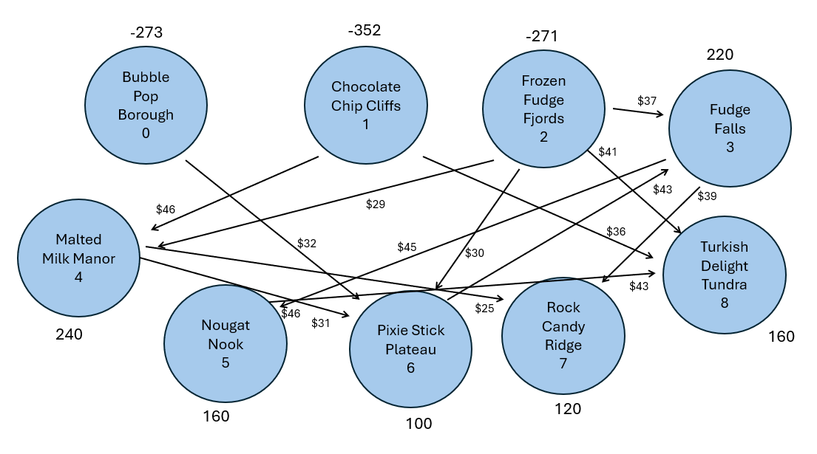

Model Formulation

*Write the formulation of the model into here prior to implementing it in your Excel model. Be explicit with the definition of the decision variables, objective function, and constraints.*

*Hint: This one differs a bit from the sample problem in terms of Balance-of-Flow*

Model Optimized for Minimal Transportation Cost

*Implement your formulation into Excel and be sure to make it neat. This section should include:*

* *A screenshot of your optimized final model (formatted nicely, of course)*
* *A text explanation of what your model is recommending*
* *Update your graph from the EDA section to bold/color the links being used (and show how much is going through that link)*

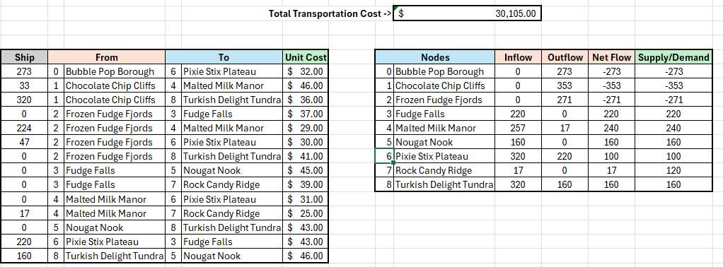

The model is suggesting exactly how much inventory to send from Node to Node so that all demand is met at the lowest total cost ($30,105), and the optimal amounts that should be shipped under the “Ship” category on the table.